**What is GDPR**

The General Data Protection Regulation is a globally accepted law that regulates the use of data – This impacts AI and AI policies as data is the core metric which allows AI to function

**What is Responsible AI?**

Responsible AI refers to an area of the AI governance framework which documents how organisations address the democratisation, legal & ethical challenges related to AI. Proponent of the field hope that a framework which is human-centred, interpretable & explainable will be widely adopted soon.

Organisations are tasked with ensuring that their use of AI maintains accountability and also ensures their use of AI is anti-discriminatory.

If noy monitored AI can create unintended consequences. Such as biases being introduced into ML models or (un)intentional misuse.

The principles of Responsible AI include:

* Comprehensiveness – clearly defining testing and governance criteria. Preventing ML from easily being hacked
* Explainable – programmed to describe its purpose, rationale & decision making process, in a manner that is understandable to an average user
* Ethical – processes in place to find, eliminate & mitigate bias in ML models
* Efficient – ability to run continually and quickly respond to changes in the operational environment

**When has AI failed, been used maliciously or incorrectly? (e.g. automated decision making – opt in and opt out options)**

Microsoft twitter box Tay tweets started making tweets about the following:

* holocaust denial
* anti semitic tweets
* Trump build a wall tweets
* Pro Hitler tweets
* Racist tweets

Microsoft alleged that Tay started making such comments after twitter users trained the bot to talk in that manner through the “trolling” nature of the twitter users conversations with the AI

**How can an Organisation ensure that they are responsible with AI & data in general?**

Ongoing scrutiny is essential to ensuring that organisations maintain responsible use of data & AI.

Search Enterprise AI also highlightlights that organisations should mandate that the technology is developed with the following standards in mins

* Shared code repositories
* Approved model architectures
* Sanctioned variables
* Established bias testing methodologies to help determine the validity of tests for AI systems
* Stability standards for active ML models, ensuring AI programming works as planned

In order to use data more responsibly Harvard business review also highlight that there should be a focus around ensuring that data is protected and its use and collection remains transparent. Only using the data available for its limited intended and ethical purpose.

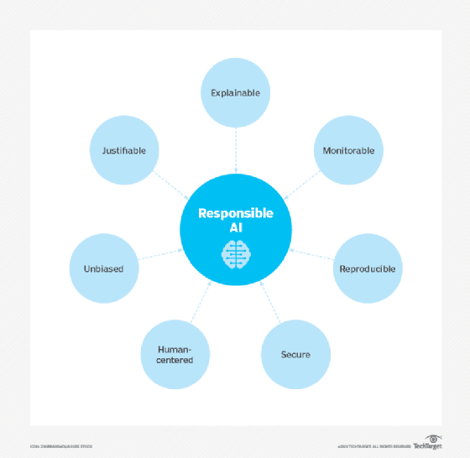

**What are the challenges associated with AI AND:**

**TIME**

The data that AI uses isn’t updated in real time and usually deals with historical data making it slightly out of touch with the present reality.

**TALENT**

According to IBM 62% of organisations struggle to acquire talent that can help deliver AI capabilities.

**TRUST**

Security & privacy – to be effective AI requires a lot of info – and as a result it may be fed personal information within the owners consent – To make matters worse, rules and regulations have not developed fast enough to define the remits of what type of data AI should be limited to or what AI can be used for